**15B – Inelastic Collision**

**Topics:** Special relativity, 4-momentum, relativistic collisions.

**Summary:** Students use conservation of relativistic 4-momentum to find the final mass of an object resulting from the merging of two colliding particles.

**Written by:** Michael Dubson, Charles Baily and Steven Pollock.

**Contact:** Steven.Pollock@Colorado.EDU

**Comments:** Students should be able to complete these tasks in less than 10 minutes. This activity was straightforward for most students, as long as they were clear on the following: definition of relativistic 4-momentum; the total momentum of a system is the linear sum of the momenta of the particles; and that this quantity is conserved before and after the collision. Some students may momentarily forget the velocity dependence of  when first working out the total momentum; the spatial velocities of the two particles cancel, but the -factor that appears in the total momentum is not also zero.



Consider the following 1-D collision: Two objects of mass , both with speeds , collide head-on and merge into a single object of mass .

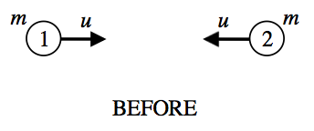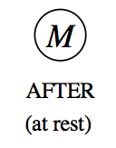

1. Write down an expression for the total 4-momentum of this system *before* the collision.
2. Write down an expression for the total 4-momentum of this system *after* the collision.
3. Solve for  in terms of  and .
4. Notice that the kinetic energy *after* the collision is less than the kinetic energy *before* the collision. Where did this energy go?
5. Check that your answer for  makes sense in the non-relativistic limit .